|  |  |
| --- | --- |
|  | **DEPARTMENT OF COMPUTER SYSTEMS ENGINEERING**  **MEHRAN UNIVERSITY OF ENGINEERING & TECHNOLOGY, JAMSHORO**  **Database Management Systems (4th Semester) 18CS**  **Lab Experiment 6** |

|  |  |  |  |
| --- | --- | --- | --- |
| **Roll No:** |  | **Date of Conduct:** |  |
| **Submission Date:** |  | **Grade Obtained:** |  |

|  |  |  |  |
| --- | --- | --- | --- |
| **Problem Recognition (0.3)** | **Completeness & accuracy (0.4)** | **Timeliness (0.3)** | **Score (1.0)** |
|  |  |  |  |

**Objective: To use Group functions in SQL queries**.

**Tools: MySQL, Oracle**

**Introduction:**

**Group Function:** Group functions are mathematical functions to operate on sets of rows to give one result per set.

**Syntax**:

The general syntax for using Group functions is:

SELECT <column>, group_function (column) FROM <table>

WHERE <condition> [GROUP BY <column>]

[ORDER BY <column>]

Note that the column on which the group function is applied must exist in the SELECT column list.

## Types of Group Function

Here are the different types of the Group function in SQL:

1. **AVG, MIN, MAX, and SUM function:** you can use AVG, MIN, MAX and SUM for numeric data.

**Syntax**:

SELECT AVG(column_name),MIN(column_name),

SUM(column_name), MAX(column_name)

FROM table1 WHERE condition*;*

1. **COUNT() Function:**

* COUNT(*) function return the number of in a table;
* COUNT (expr) returns the number of rows with non-null values for the expr.
* COUNT (DISTINCT expr) returns the number of distinct non-null values of the expr.

**Syntax:**

SELECT COUNT(Column_name)  
FROM table1  
WHERE condition*;*

1. **NVL() Function:** The NVL() function forces Group functions to include the null values.

**Syntax:**

SELECT NVL(column_name) FROM table11;

**Lab Task**

1. **List out the department numbers that have at least 4 employees.**

**Task:**

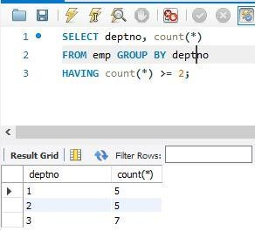

1. **Display the number of employees in each department.**

**Task:**

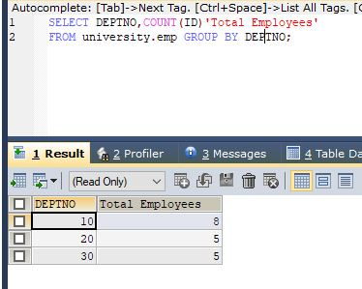

1. **Display the manager no and the salary of the lowest paid employee for that manager. Exclude anyone whose manager is not known. Exclude any groups where the minimum salary is less than 1000. Sort the output in descending order of salary.**

**Task:**

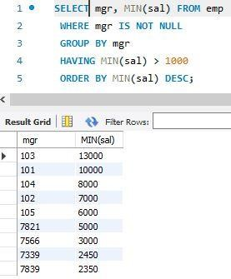

1. **Find the most recently hired employee in each department.**

**Task:**

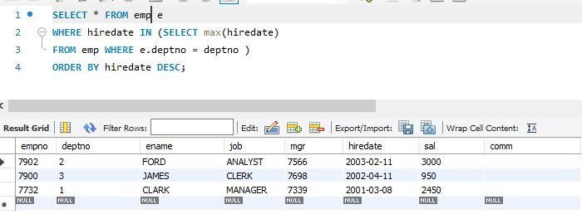

1. **List the highest salary paid for each job.**

**Task:**

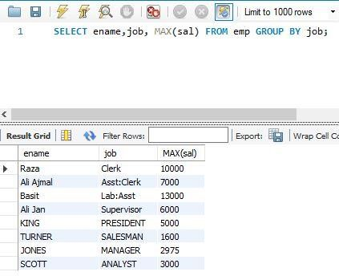

1. **Display the department number, number of employees in that dept and the average salary for all employees in that department. Round the average salary to two decimal places.**

**Task:**

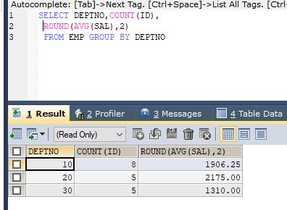

1. **Write a query that will display the difference between the highest and lowest salaries. Label the column DIFFERENCE.**

**Task:**

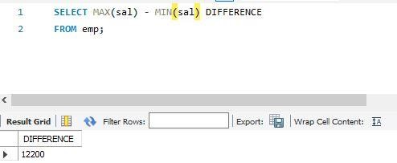

1. **Display the number of employees with same job.**

**Task:**

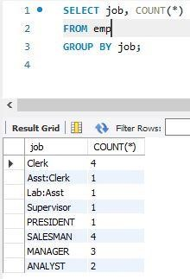

1. **Determine the number of managers without listing them. (Hint: Use MGR column)**

**Task:**

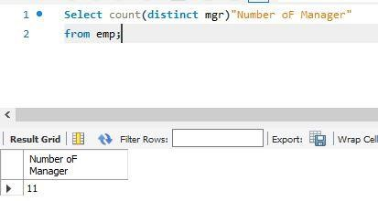

**10. Display the job title and total monthly salary for each job title with a total payroll exceeding 5000. Exclude salespeople and sorts the list by the total monthly salary.**

**Task:**

